Read Me
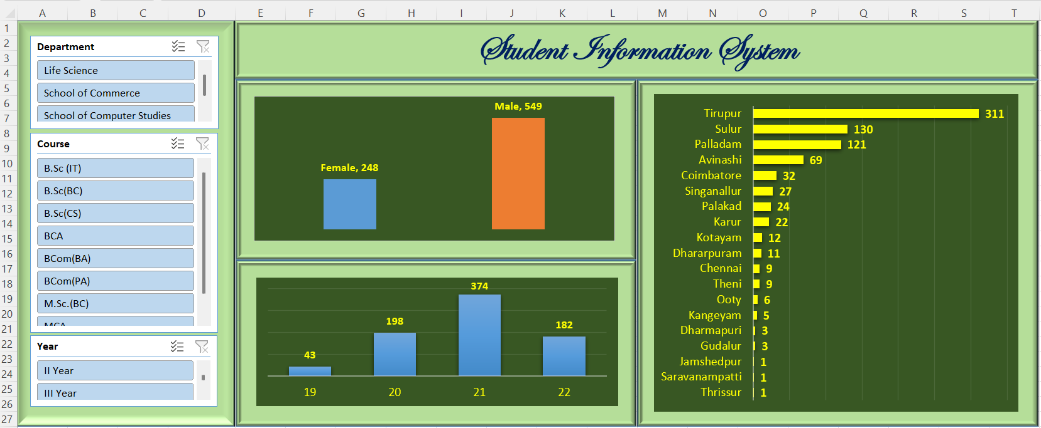

1. Student Strength KPIs
These are the headline numbers.
- Total Students
- Total Courses Offered
- Total Departments
- Active Batch
- Current Academic Year

2. Gender Diversity KPIs
Useful for academic reporting & accreditation.
- Male Students
- Female Students
- Male %
- Female %
- Gender Ratio (M:F)
📊 Great KPI for pie or donut chart

3. Age & Demographic KPIs
Good for student profile analysis.
- Average Age
- Youngest Student Age
- Oldest Student Age
- Age Range

4. Geographic Distribution KPIs
Very useful for regional outreach analysis.
Town-wise Students
- Tirupur
- Palladam
- Sulur
District-wise Students
- Tirupur District
- Coimbatore District
State-wise Students
- Tamil Nadu
📍 Ideal for bar chart or map visualization

5. Course & Department KPIs
Useful for department-level dashboards.
- Course Concentration
- Department Strength
- Average Age by Department
- Gender Mix in Department
  - Male
  - Female

6. Batch & Academic Progress KPIs
Good for academic planning.
- Batch Year
- Students in Final Year
- Batch Completion Readiness

7. Date-based / Age Validation KPIs
Useful for data quality & teaching date functions.
- Age Accuracy Check → DOB vs Today matched ✔️
- Students Turning 28 This Year
- Students Below 27

8. Suggested KPI Tiles for Excel / Power BI
Top row KPIs you can show as cards:
- Total Students
- Male %
- Female %
- Average Age
- District Coverage
- Town Coverage

9. Bonus (Perfect for MBA / Analytics Lab)
You can ask students to:
- Create Pivot Tables
- Design Gender vs Town dashboard
- Use COUNTIFS, AVERAGEIFS
- Build interactive slicers (Course, Gender, Town)

